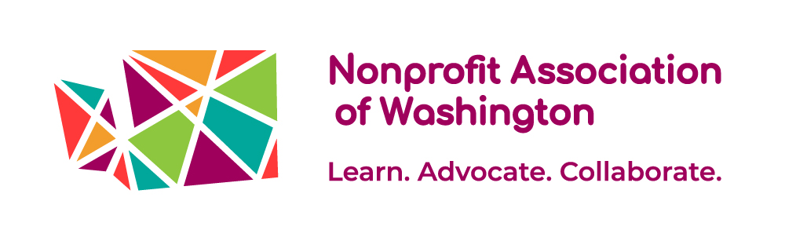
BOARD MEMBER POSITION PROFILE

About Nonprofit Association of Washington
The Nonprofit Association of Washington convenes a powerful network of nonprofit organizations across Washington State to learn, advocate, and collaborate, so that nonprofits can achieve their missions. Our vision is a vibrant nonprofit sector that is a valued partner in strengthening communities.
Through participation in our network, nonprofits (staff, board, and volunteers) become more sustainable and effective in achieving their missions. Stronger nonprofits contribute to healthy, collaborative, economically vital, and civically engaged communities. Our organization is becoming more equitable and elevating equity throughout the nonprofit sector.
We work in three program areas: learning, advocacy, and collaboration. Our learning program reached over 8,000 people through 150 learning events in 2021. Our public policy advocacy led to the 2021 passage of the Washington Nonprofit Corporation Act, a comprehensive update of the state statutes governing nonprofits. Our collaboration focus includes community engagement to increase our membership and ensure that nonprofits based in marginalized communities, including BIPOC-led and rural nonprofits, have access to all the resources we provide. We are nimble and responsive in changing times. We mobilized nonprofits to get out the count for the 2020 census, and we played a crucial role in helping nonprofits navigate rapid change and crisis during the pandemic.
The organization’s annual budget has grown to over $1.5 million, with a staff of 13. Support for WN’s work comes from private foundations, the Washington State Office of the Secretary of State, conference and workshop fees, business sponsors, and our over 600 members.
Learn more about NAWA at www.nonprofitwa.org.

Board Member Summary
Washington Nonprofits seeks board members who bring a powerful combination of visionary leadership, social networks, nonprofit experience, and business savvy to help us grow to the next level of organizational and sector-level excellence. Board members will work closely and collaboratively with NAWA’s Executive Director (ED), staff, fellow volunteers, and partners to advance the nonprofit sector in Washington State. The Board along with NAWA’s ED will shape and communicate the vision and strategic direction of NAWA, acquire resources equal to its vision, and ensure that the organization is well managed, equitable, and accountable to the membership.

NAWA is a network organization, highly dependent on a wide array of partners to accomplish its work. The board is instrumental in developing and maintaining relationships along with its staff. Board members should be committed to growing NAWA’s membership.

Board members are instrumental in shaping the strategic direction of NAWA as it moves from a start-up to an influential player in nonprofit, government, and philanthropic circles. An understanding of the strengths and needs of the nonprofit sector is required, as well as an openness to ongoing learning from our members and partners. We believe that a diverse board that brings multiple perspectives and life experiences is essential to good governance.

Key responsibilities
- Equity: Ensure equity is an organizational priority to ‘recognize and eliminate systemic racism and marginalization and to promote inclusion and antiracist practices.’
- Strategy development: Along with the ED, develop and implement a strategy to grow WN and achieve our mission of a strong, connected nonprofit sector.
- Program oversight: setting the vision and strategic direction of the organization and monitoring our progress.
- Executive alliance: Support and evaluate the CEO and foster a healthy organizational culture.
- Fundraising: Board members are expected to make an annual monetary contribution to the organization at personally meaningful. Board members should encourage nonprofits to become members. Board members can support staff efforts to solicit funds from a variety of sources and ensure that the organization has the resources to accomplish its work.
- Financial review: Ensure maintenance of sound financial records, operation within budgetary constraints, and compliance with legal and regulatory standards.
- Service: Board members are initially elected to serve a two-year term and may serve up to three consecutive terms. Board members are expected to:
  - Attend board meetings (up to 3 in person and up to 6 by teleconference per year) and attend an annual in-person board retreat. As a statewide association, some board meetings will require travel. Board members may request reimbursement for all travel and lodging costs.
  - Participate in various ad hoc projects and/or serve on one or more committees (equity, policy, board development, executive).
  - Advocate for NAWA and promote its programs and activities. Participate in NAWA’s events and advocacy campaigns as appropriate to their time and availability.
  - Join NAWA and/or advocate that nonprofits you are affiliated with become members.

Profile of the Successful Candidate
The successful candidate will be an inspiring volunteer who is able to represent the organization and work well with a wide range of partners while also building a strong board and staff team and a healthy organization. We are committed to have a board that represents the racial, cultural, age, and geographic diversity of our state, and invite candidates from the public, private, and nonprofit sectors. As of Winter 2023, we are particularly seeking to add people of color, young professionals, and rural residents. We also would like to add regional representation from Northwest Washington, North Central Washington, Eastern Washington/Spokane, and the South Puget Sound area.

We are seeking candidates with the following qualifications:
- Deep knowledge and/or passion for the nonprofit sector in Washington state
- Collaborative leadership style
- Demonstrated commitment to equity & brings an equity lens to the work of the board
- Highly trustworthy
- Philanthropic and oriented to service
- Ability to travel statewide for up to three meeting per year (travel, lodging, and other costs that may create barriers to participation, such as childcare, can be paid by the organization.)

In addition, we are seeking to add the following skill sets to our board:
- Experience working for equity and social justice
- Willingness to help us connect with new partners and invite others to join our organization
- Financial management expertise
- Legal expertise

Join Us!
To apply: If you are interested in exploring board membership at NAWA, we encourage you to apply by submitting your resume and a letter or email detailing your interest and how you hope to contribute to laura@nonprofitwa.org. Questions directed to Laura Pierce are welcome prior to application.

